Mission Critical - Players' And Level Designers' Guide
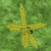
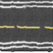
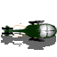
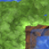

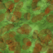



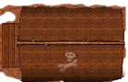
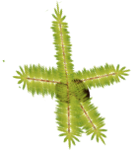
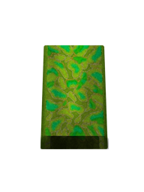
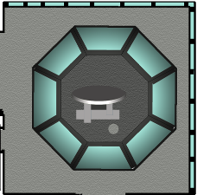



Table of Contents

Mission Critical - Players' And Level Designers' Guide 1
Installation Instructions 2
Introduction 2
Features: 3
Playing the game 3
Developing levels 4
Play Game 4
Sprite Placement 7
Properties 8
Animation Properties 8
GameObjectDialogProperties 9
Path Drawing 9
Scripts 10
Irregular Polygon Creation Program 10
Known Issues And Bugs/Defects 10
Future Updates 11



Installation Instructions
- Download Mission Critical Setup files
- Run dxwebsetup.exe
- run Mission Critical Setup files

Introduction
GNU image manipulation program has been used to develop sprites and tiles. Animation for the soldier was completed in Adobe Flash CS 5 and then exported as a list of images. An application called SpriteGenerator has then been downloaded and used to make one big image from the list. This list can then be imported as a png image file and animation properties set to have an animated walking soldier from above.

Nicholas Castleton has used photoshop at various stages to develop the bunker, AAGUN and airport. And also an AAGUN bullet.

Mark Leman has given input into the shape and development of the game and has designed the first level.

Features:
Line Line collision detection backed up with an irregular polygon creation tool developed using C# .Net. This application is used to draw a series of connected lines around a png image to make up an Irregular Polygon. A file with the name in the following format is then exported: <imagename>_points.txt.

This file is then picked up automatically if present by the main game and used for line line collision detection with the bullets.

This has been done to improve the accuracy of projectile sprite collision detection. This kind of collision detection is only performed on projectile sprite.

Point to Axially aligned bounding box is used for the wandering soldiers when detecting collisions.
The wandering behaviour of the tanks has been switched off and it is recommended that a path be drawn for tanks to follow. This makes more sense because tanks in combat do not wander they follow strategic routes.

Tiles in the video game can be set as a nogo area meaning wandering sprites such as soldiers will turn away from these tiles when close by.

This limitation would be best resolved because it means tanks will drive over trees and water if no path is set or the path/route goes through them.

Playing the game

The aim of the game is to destroy all AAGUNS at present and rescue comrades.
There is a sprite protect mode shown in level 3. Where if the sprite marked as protected is destory then the player is destroyed. This would be good for convoy protection levels.
Another feature started is resources, where if no power stations the AAGUNS are not powered and can easily be terminated.

WADS keys for up, down left and right. There is a helicopter bank function, but it is no longer enabled. Consideration of moving to num key pad for controls is taking place. Having 1, 3, 7, and 9 for diagonal movement is an easy option.

SPACE – fires bullets
ENTER – every 5 seconds is possible to fire a side winder to destroy tanks or AAGUNs quickly.

Cursor keys
UP – move forwards
DOWN – move backwards
LEFT – rotate anti clockwise
RIGHT – rotate clockwise

To load a level normally starting with Level 1 choose Script>Load and Run Lua Script. Choose the script in the working directory. Select okay again and the level should load within a few seconds.

Please note if the sound files are missing from the application the application will not start. This can be programmed to keep running but its better for users to get the full experience of the 3D sound in a 2D plane.

The 3D sound works by the position of the helicopter and explosions on the screen. The helicopter blades sound always plays through the centre in the front of the user.

Explosions either left or right positioning in front of the player depending on the positioning on the VDU.

Developing levels
Edit modes are:

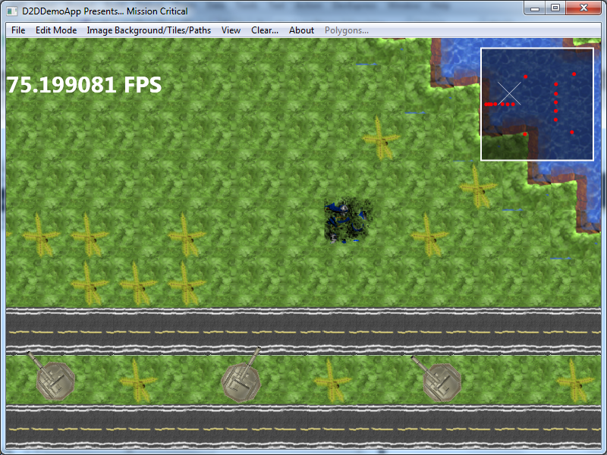
Play Game
  - Just runs the game, both direct input, object updating and rendering executed.
  - Head Up Display – 75.199 FPS is the frames per second drawn. Input, Sound, Updating and Rendering is done each frame.
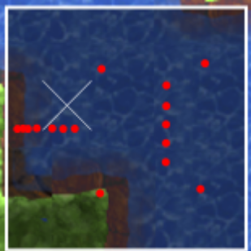
  - The image above shows the minimap. It is as wide and high as the tiled map. Red circles are shown for the enemies and Green dots for the protected sprites. The white cross is the helicopter.
  - For all sprites are total hit count can be set for the game engine to count how many hits each sprites takes then remove it from the map. This can be set using the GameObjectDialog properties screen shown below. This screen can be awkward in low screen resolutions because it is not scrollable yet.
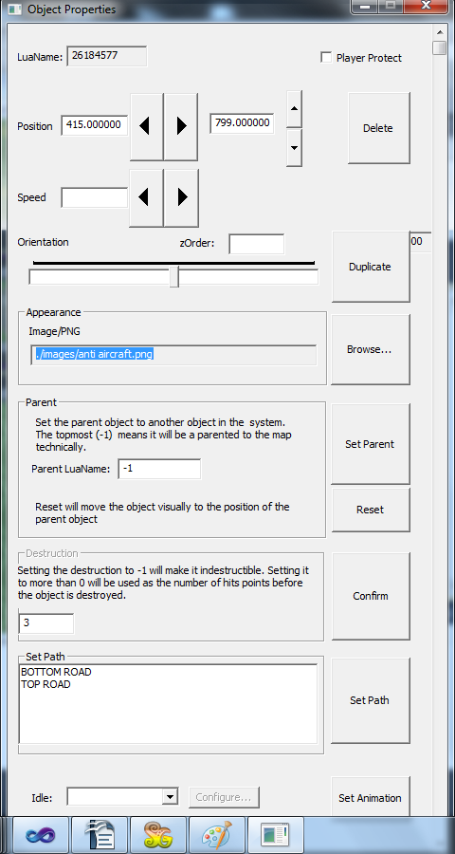
- Edit Tiled Map
  - A grid will be drawn on the screen of thick grey lines. The grid might be removed in future. Tiles should be 32x32 pixels.
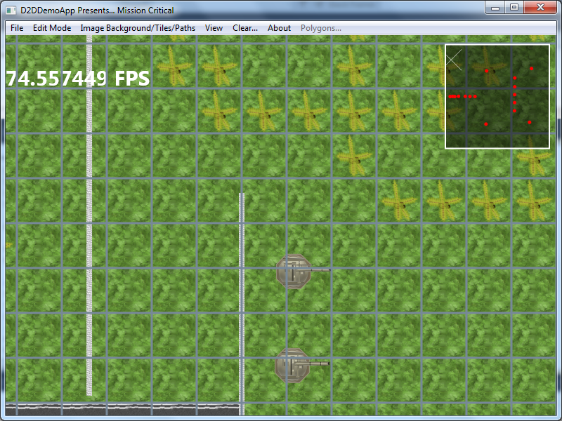
  - Each square is left clicked to write a tile.
  - Right clicking a tile will choose the tile as the painting tile.
  - Holding the left mouse button down and scrolling over other squares will set the tile.
  - The View>>Set Resolution and map extents alter the window resolution and the map width and height. Once these are set you cannot move out of this game area.
  - Use up down, left and right cursor keys in this mode to scroll across the map.

Sprite Placement

This is where the game sprites are placed. Right clicking and selecting from the following menu will do the following actions.

Left clicking and dragging a sprite will move it around the viewable game area on screen.

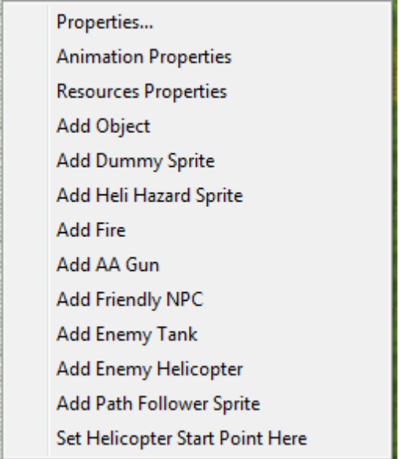
Properties
Edit the existing properties for the closest sprite to the mouse cursor. The brings up the Game Object Dialog.

Animation Properties
Sets the animation properties for the sprite with the dialog below.
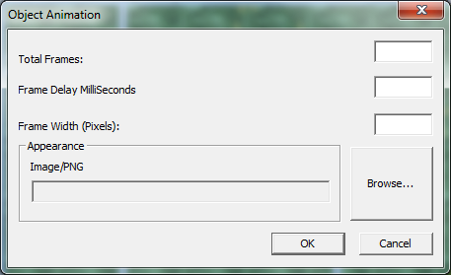
Total frames is how many frames wide the selected imaged browsed for is. The frame delay in milliseconds. For example 25 frames per second would be 1000ms/25frames/second = 40

Once these are set when exporting to luascript these are also exported. The frame width is the width of each individual frame within the image. They should all be the same. When the file has been chosen and these properties set select submit and the sprite will be animated.

The animations run in a constant loop so animation with two frames will run in the following way regards to frame numbers. 1,2,1,2,1,2....

GameObjectDialogProperties

LuaName is the unique identifier for the selected sprite.
Position and Orientation are self explanatory.
Speed may not work. This is likely to be removed in future releases.
The zorder is not implemented.
Appearance – is the url, which can be changed for selected and displayed image.
Parent is as in a scene graph self explanatory. It will copy the transformations applied to the parent.
A lua id needs to be entered into the input box.
This is not really used.
Destruction – Self explanatory.
Set Path: When paths have been drawn in path edit mode they can be chosen by name and then set path will make the sprite follow this path when in a viewed area.
Animation – would have been predefined animation functions which is no longer used.

Keyboard and mouse control
Numpad 0 – duplicate a sprite in the direction of its orienation one image width in front.
PLUS – rotate clockwise
MINUS – rotate sprite anti clockwise
Clicking in the middle of the selected sprite and dragging will move the sprite around the viewable area on screen.
Delete key will delete the closest sprite.

Path Drawing
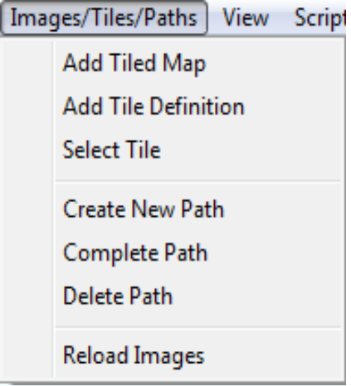
Create New path will open a dialog to enter the name for the path.
Submit the name. Make sure the application is in edit path mode.

Then click to place the waypoints for the path. When the path is complete choose complete path from the Image Background/sprites and paths menu.

Now in sprite edit mode go to game object dialog for a sprite and set the path to the name you have chosen in the set path frame/group box.

This process can be completed for any number of paths.

The delete path functionality does not yet work correctly.

In path edit mode the paths are drawn on the screen in black as connected lines.

When a sprite is following the path and it gets to the end way point it will then go back to the first way point so it is good practice to loop the paths.

Scripts

Use the scripting menu under file menu to manage the level scripts.

When a level is complete choose Generate Lua Script and select a directory. Above the images folder (the working directory) to save the scripts.

Before generating the script it may be best to set the next level script by choosing a lua script file through the open file dialog shown from the menu.

Irregular Polygon Creation Program

Not yet included.

Known Issues And Bugs/Defects

Edit Tiled map mode.
When moving the mouse too quickly tiles can be changed in random places. The cause has not yet been determined or looked into.

Please back up all your level files as it is too easy overwrite another game file.

Its too easy to overwrite another level file.

Delete paths functionality does not work correctly

sprites can jump to zero zero coordinates occasionally.

Pressing the game keys while in another application still effects the game eventhough the window does not have focus. I think this is a direct input issue. When the app no longer has focus it should pause the game.
Some dialog boxes are not properly populated on load.

Future Updates

Various helicopters with unique abilities
Better AI
Different environments
End of level scores
More interesting missions and features
Electric fences including electrifying animation for soldiers
Better particle effects when producing explosions.
Android App – the plan with this is produce an android app the replicates the same gameplay and level loading.

